****Project Objective:****

**As a developer, write a program to read, write, and append to a file.**

****Background of the problem statement:****

**As a developer, write a Java code to read, write, and append to a file**.

**Source Code :-**

import java.io.BufferedReader;

import java.io.File;

import java.io.FileNotFoundException;

import java.io.FileReader;

import java.io.FileWriter;

import java.io.IOException;

import java.io.InputStreamReader;

import java.util.Scanner;

public class FileHandling

{

public static void main(String args[]) throws FileNotFoundException, IOException

{

System.out.println("Please select one of the below operations");

System.out.println(" w for write mode ");

System.out.println(" r for read mode ");

System.out.println(" a for append mode ");

Scanner in =new Scanner(System.in);

String s=in.nextLine();

if(s.equalsIgnoreCase("r"))

{

new FReading();

}

else if(s.equalsIgnoreCase("w")||s.equalsIgnoreCase("a"))

{

writingToFile(s);

}

else

{

System.out.println("Sorry you try to do unexpected ,betterluck next time ");

}

in.close()

}

public static void writingToFile(String s)

{

Scanner in=null;

try

{

String source = "";

File f=new File("file1.txt");

BufferedReader bf=new BufferedReader(new InputStreamReader(System.in));

FileWriter f0 =null;

if(s.equalsIgnoreCase("w"))

{

f0 = new FileWriter(f,false);

System.out.println("CAUTION >> Please understand it will overwrite the content of the file ");

System.out.println("Type 'no' to exit");

System.out.println("Do you want to proceed :type 'yes' ");

in=new Scanner(System.in);

String s1=in.nextLine();

if(s1.equals("no"))

System.exit(0);

System.out.println("Write 'stop' when you finish writing file ");

f.delete();

f.createNewFile();

while(!(source=bf.readLine()).equalsIgnoreCase("stop")) {

f0.write(source + System.getProperty("line.separator"));

}

in.close();

}

else

{ f0 = new FileWriter(f,true);

System.out.println("Write 'stop' when you finish appending file ");

while(!(source=bf.readLine()).equalsIgnoreCase("stop")){

f0.append(source+ System.getProperty("line.separator"));

}

}

f0.close();

}

catch(Exception e){

System.out.println("Error : " );

e.printStackTrace();

}

}

}

class FReading {

public static String str="";

public FReading() {

try{

File f5=new File("file1.txt");

if(! f5.exists())

f5.createNewFile();

FileReader fl=new FileReader(f5);

BufferedReader bf=new BufferedReader(fl);

while((str=bf.readLine())!=null){

System.out.println(str);

}

fl.close();

}catch(Exception e){

System.out.println("Error : " );

e.printStackTrace();

}

}

}

**Output :-**

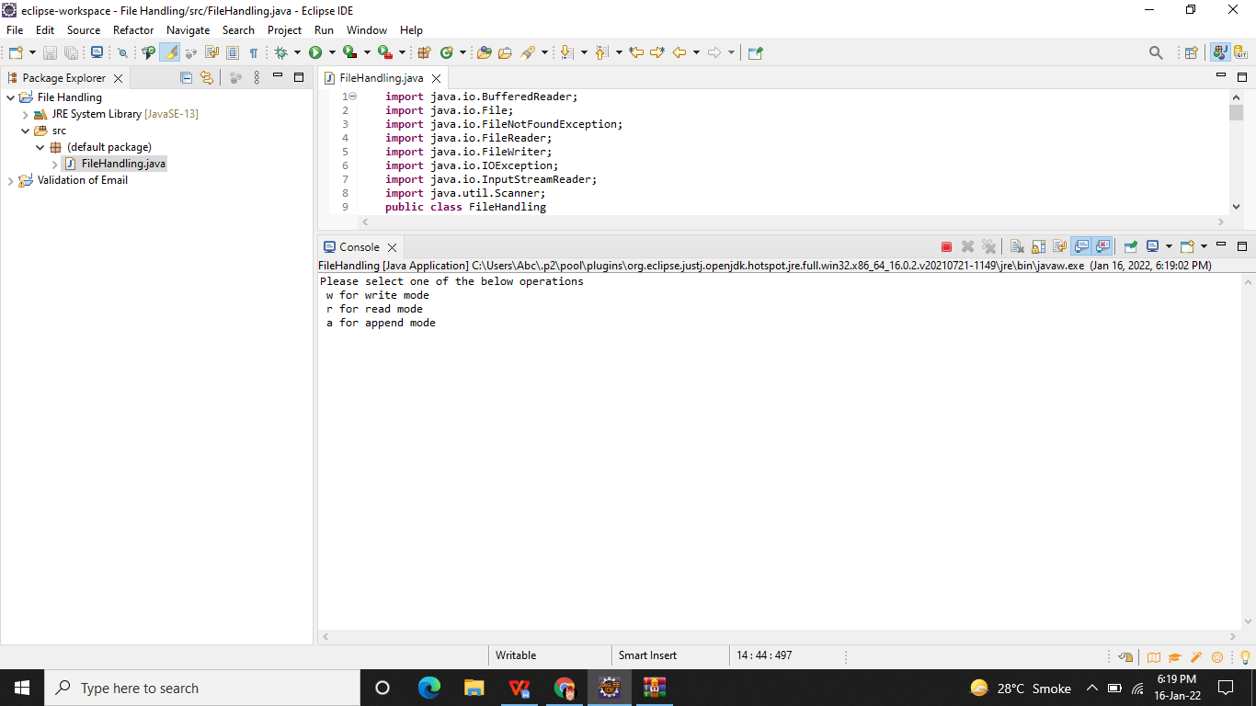

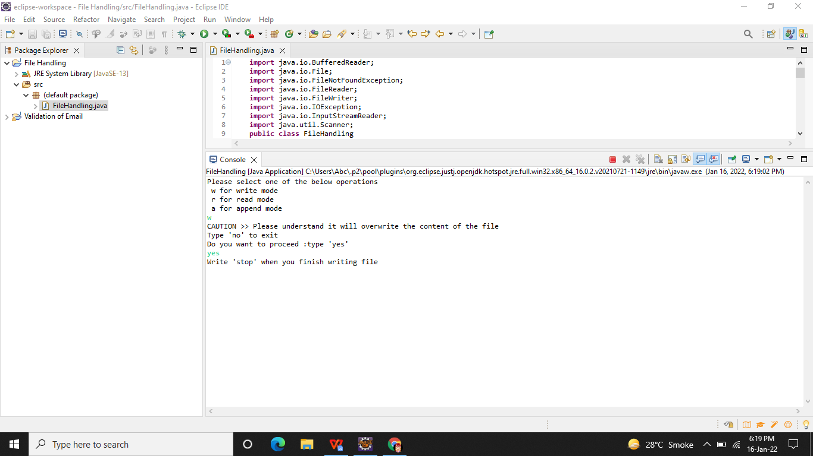

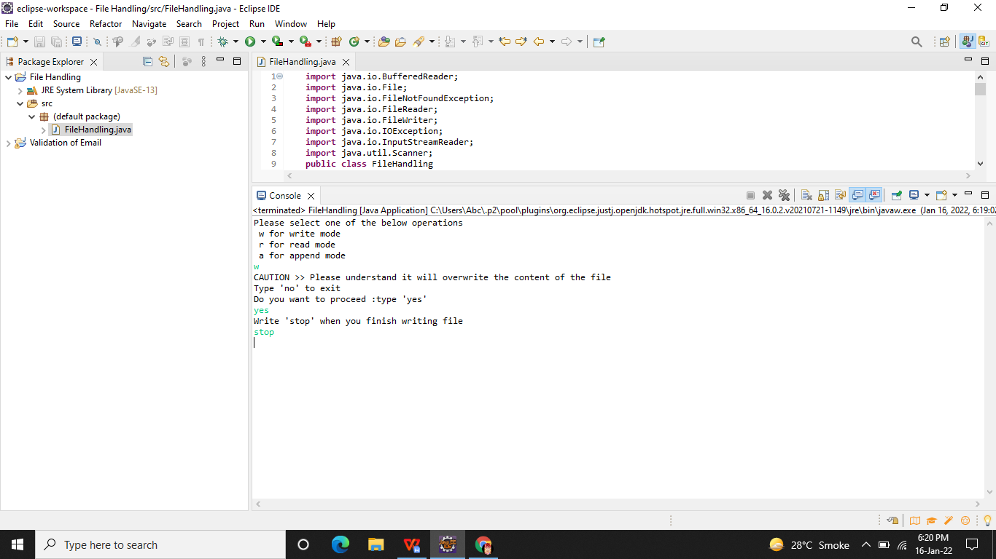

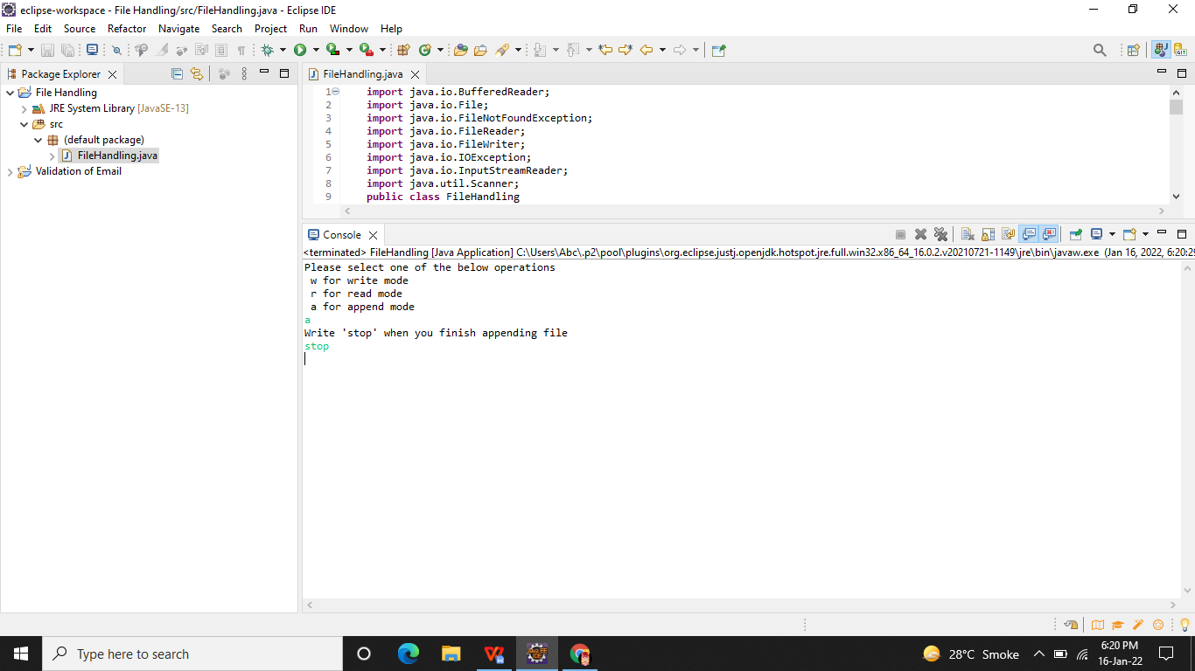

**Github Link -**

**https://github.com/Aniket03-op/Project.git**